Files and Exceptions - Student booklet
Y13 - Cambridge International 9618 | 20.2 File processing and exception handling
Name: _______________________________ | Date: _____________

- Learn sections show the key slides. Read them, then do the task straight after.
- Paper 3 questions are written in pseudocode; Paper 4 questions are VB.NET at the computer.
- Your teacher will share the answers. Task 6 needs TheData.txt from your teacher.
Task 1 Starter: spot the errors [4 marks]
The program should output every line of Scores.txt, then add one line to the END of Log.txt. There are four errors. One of them is something that is missing.
1 Dim Reader As New IO.StreamReader("Scores.txt")
2 While Reader.EndOfStream
3 Console.WriteLine(Reader.ReadLine())
4 End While
5 Dim Writer As New IO.StreamWriter("Log.txt")
6 Writer.WriteLine("Scores read at " & Now())
7 Writer.Close()
Line | Error | Correction
Learn File modes, organisation and access
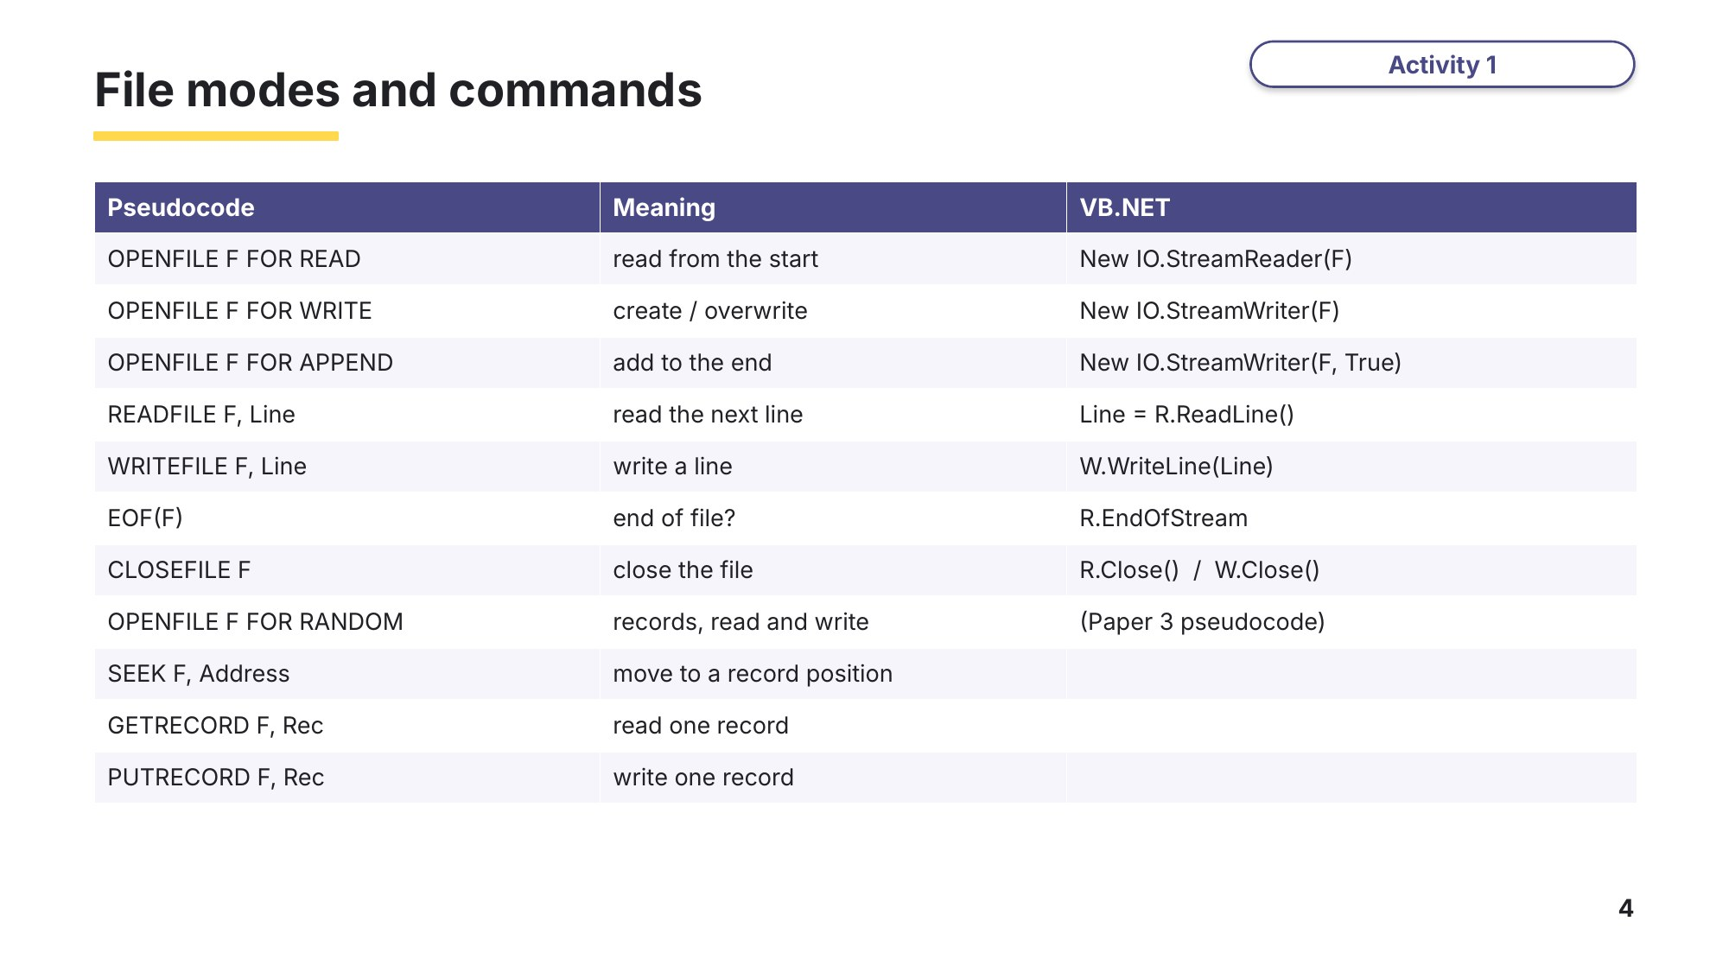
Slide 4 - File modes and commands
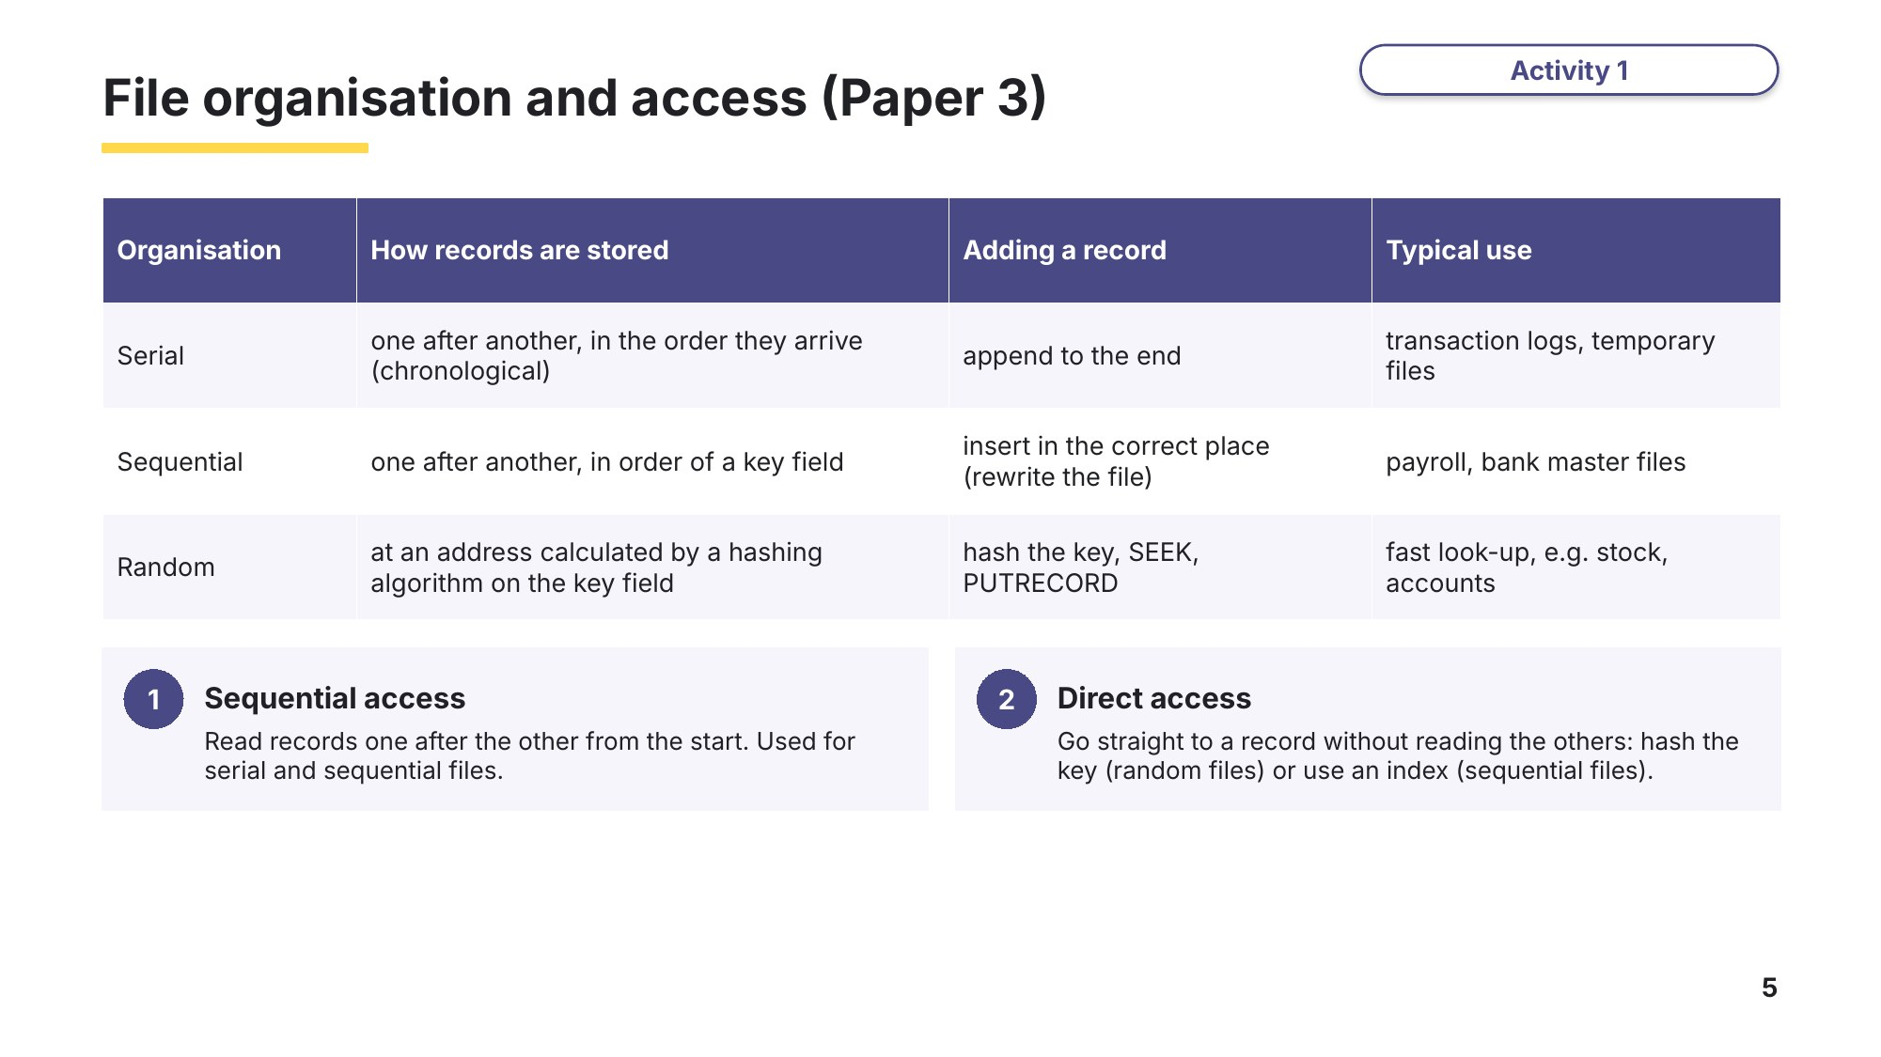
Slide 5 - File organisation and access
Task 2 Understand and trace [12 marks]
Part A File organisation (Paper 3)
9618/31 October/November 2021 Q5
(a) Compare sequential and serial methods of file organisation. [4]

(b) State the most suitable method of file access when a record is referenced by a unique address on a disk-type storage medium. [1]

(c) State the most suitable method of file access when a bank stores its data records in ascending order of account number. [1]

Learn Exceptions
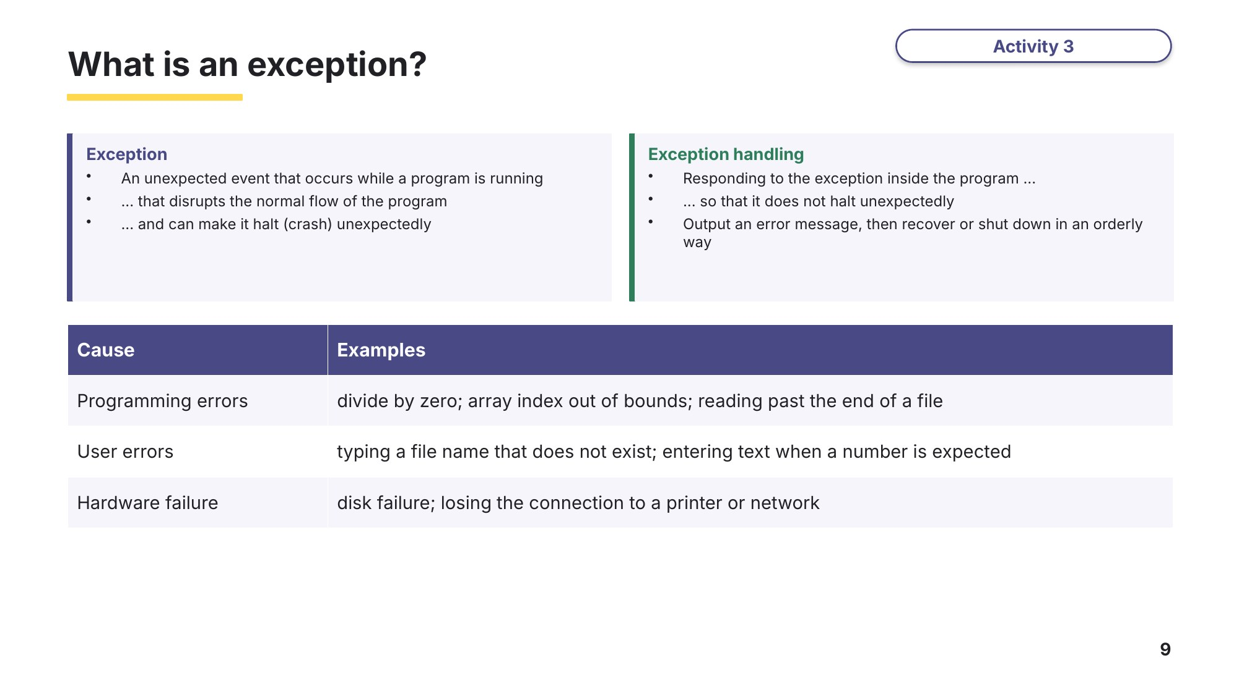
Slide 9 - What is an exception?
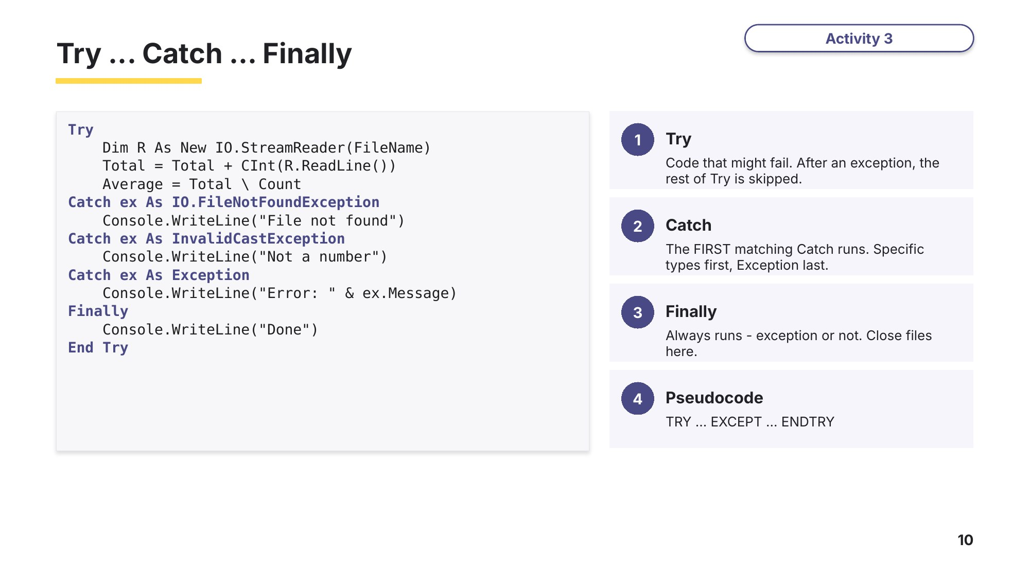
Slide 10 - Try ... Catch ... Finally
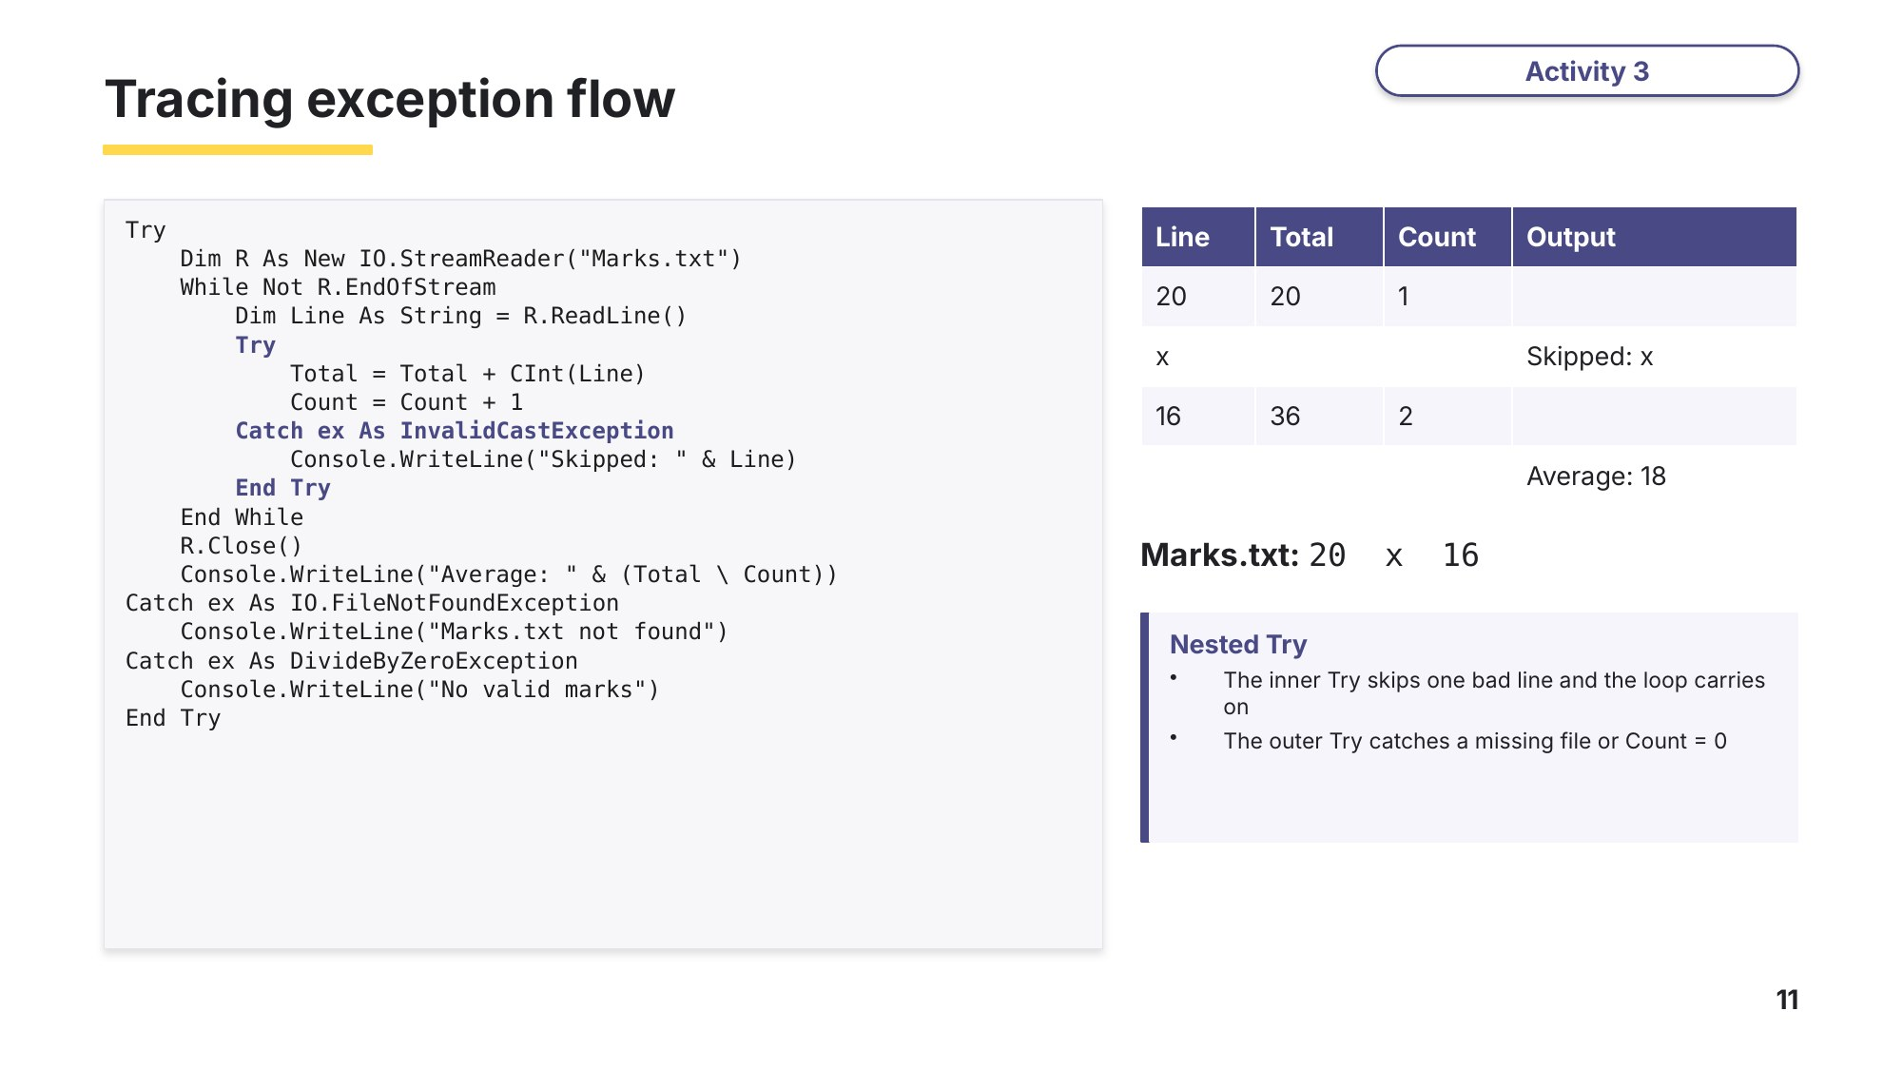
Slide 11 - Tracing exception flow
Part B Trace the exception flow
Study this program. Integer division (\) by zero throws a DivideByZeroException; CInt throws an InvalidCastException if the text is not a whole number.
Sub Main()
Dim Total As Integer = 0
Dim Count As Integer = 0
Try
Dim R As New IO.StreamReader("Marks.txt")
While Not R.EndOfStream
Dim Line As String = R.ReadLine()
Try
Total = Total + CInt(Line)
Count = Count + 1
Catch ex As InvalidCastException
Console.WriteLine("Skipped: " & Line)
End Try
End While
R.Close()
Console.WriteLine("Average: " & (Total \ Count))
Catch ex As IO.FileNotFoundException
Console.WriteLine("Marks.txt not found")
Catch ex As DivideByZeroException
Console.WriteLine("No valid marks")
End Try
End Sub
(a) Marks.txt contains four lines: 12, 15, abc, 9. Write the exact output. [2]

(b) Marks.txt contains two lines: x and an empty line. Write the exact output. [2]

(c) Marks.txt does not exist. Write the exact output. [1]

(d) In (b) the file R is never closed. Explain why, and how the program could be changed so that R is always closed. [1]

Learn Reading and writing text files
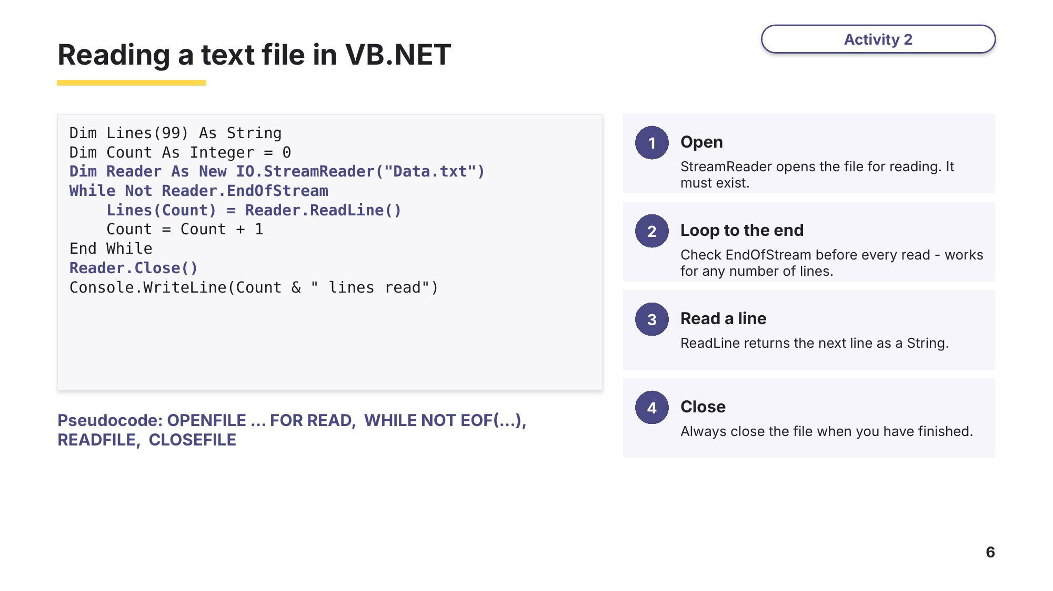
Slide 6 - Reading a text file
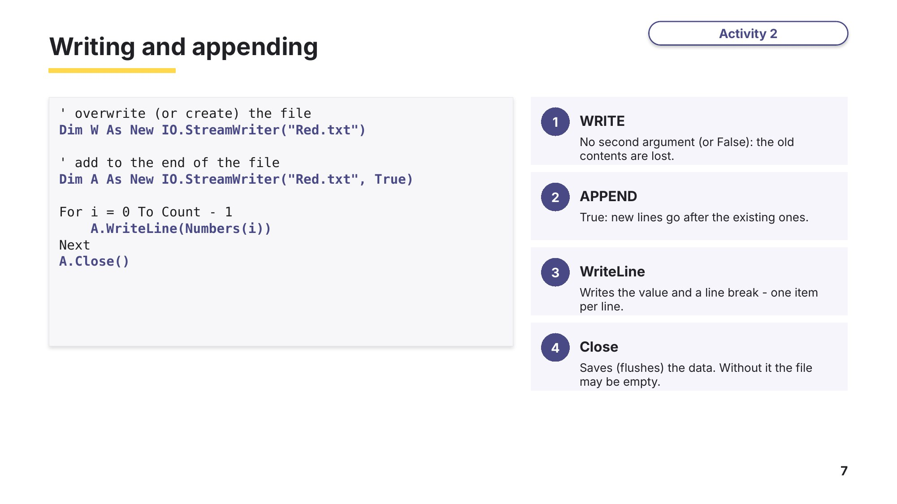
Slide 7 - Writing and appending
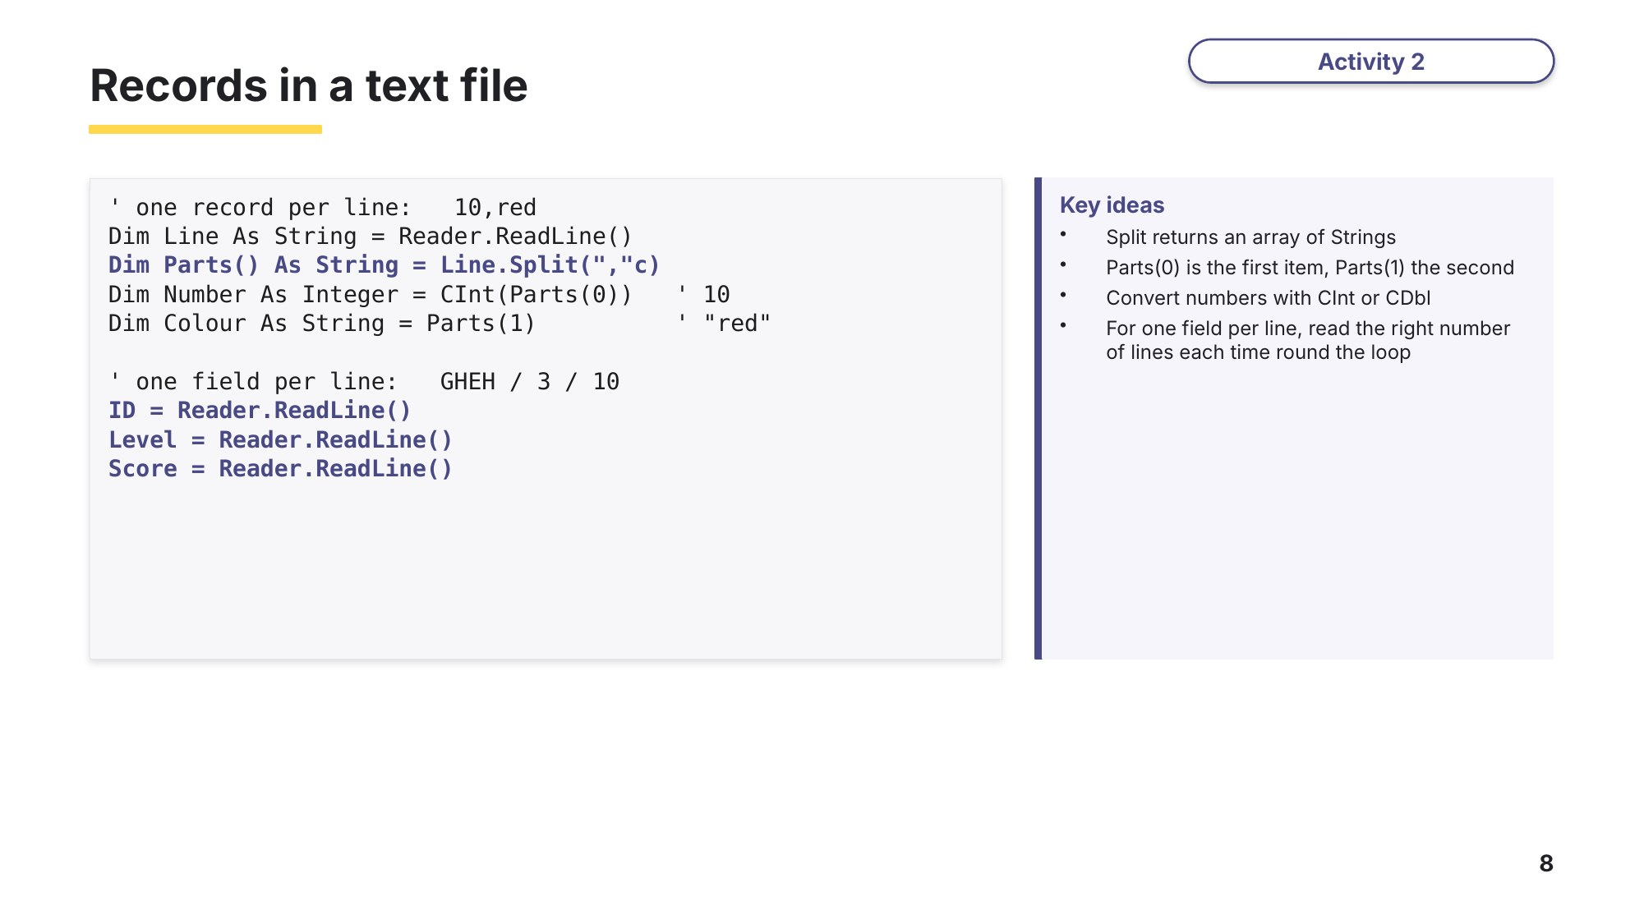
Slide 8 - Records in a text file
Task 3 Complete the code [15 marks]
Part A Read a file into an array (VB.NET)
ReadScores() reads every line of a text file into an array of integers. If the file does not exist it outputs a message instead of crashing. Complete the five gaps.
Function ReadScores(FileName As String) As Integer()
Dim Scores(99) As Integer
Dim Count As Integer = 0
(1) ........................
Dim Reader As New IO.StreamReader(FileName)
While Not Reader.(2) ........................
Scores(Count) = CInt(Reader.(3) ........................)
Count = Count + 1
End While
Reader.(4) ........................
Catch ex As (5) ........................
Console.WriteLine("File not found: " & FileName)
End Try
Return Scores
End Function
Gap | Answer
(1)
(2)
(3)
(4)
(5)
Part B Copying a text file (Paper 3)
9618/31 May/June 2023 Q10
The pseudocode algorithm shown copies an active accounts text file ActiveFile.txt to an archive accounts text file ArchiveFile.txt, one line at a time. Any blank lines found in the active accounts text file are replaced with the words "Account not present" in the archive accounts text file. Complete this file-handling pseudocode.
Write the missing code for gaps (1) to (5). [5]
DECLARE Account : STRING
(1) ........................
OPENFILE "ArchiveFile.txt" FOR WRITE
WHILE NOT (2) ........................
READFILE "ActiveFile.txt", Account
IF Account = "" THEN
WRITEFILE "ArchiveFile.txt", "(3) ........................"
ELSE
WRITEFILE "ArchiveFile.txt", (4) ........................
ENDIF
ENDWHILE
(5) ........................
CLOSEFILE "ArchiveFile.txt"
Gap | Answer
(1)
(2)
(3)
(4)
(5)
Learn Random and sequential files
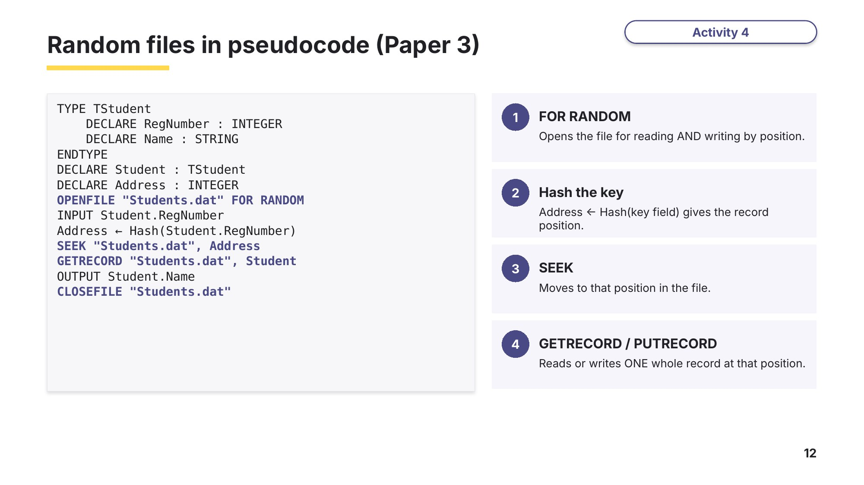
Slide 12 - Random files in pseudocode
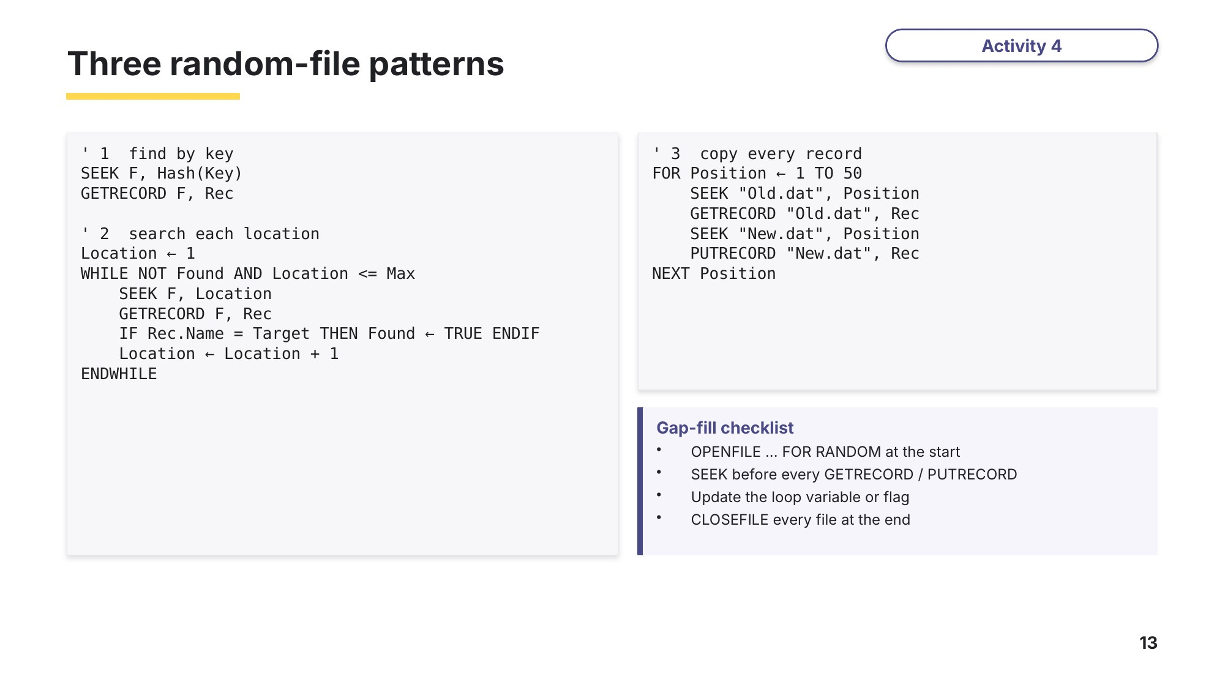
Slide 13 - Three random-file patterns
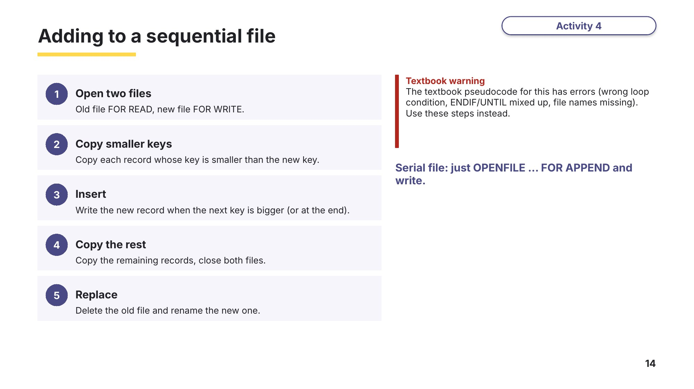
Slide 14 - Adding to a sequential file
Part C Storing a new item in a random file (Paper 3)
9618/33 May/June 2025 Q11
The pseudocode algorithm below allows a user to input a new stock item. The random file is searched for the next empty location in the file and the new item is inserted there. A suitable message is displayed if the file is full. Complete this pseudocode.
Write the missing code for gaps (1) to (5). [5]
DECLARE Location : INTEGER
DECLARE NewStock : STRING
DECLARE CurrentStock : STRING
DECLARE Stored : BOOLEAN
DECLARE Max : INTEGER
Max ← 100000
Stored ← FALSE
Location ← 1
(1) ........................
OUTPUT "Enter the new item you wish to store: "
INPUT NewStock
WHILE NOT Stored AND Location <= Max
(2) ........................
GETRECORD "StockList.dat", (3) ........................
IF CurrentStock = "" THEN
(4) ........................ "StockList.dat", NewStock
Stored ← TRUE
ELSE
Location ← Location + 1
ENDIF
ENDWHILE
(5) ........................ THEN
OUTPUT "The new item has not been stored as the file was full."
ENDIF
CLOSEFILE "StockList.dat"
Gap | Answer
(1)
(2)
(3)
(4)
(5)
Task 4 Exam questions [22 marks]
Part A Exceptions (Paper 3)
9618/33 October/November 2025 Q12
An exception can occur when running a program.
(a) Explain what is meant by an exception. [3]

(b) Identify one example of an exception and give one reason why the exception may cause a problem. [2]
Example

Reason

Part B Finding a record in a random file (Paper 3)
9618/31 October/November 2023 Q8
(a) A pseudocode algorithm finds a customer account record in a random file and outputs it. The records are stored using the user-defined data type TAccount. The function Hash() takes the customer account number as a parameter, calculates and returns the hash value. Complete the file handling pseudocode. [5]
TYPE TAccount
DECLARE AccountNumber : INTEGER
DECLARE LastName : STRING
DECLARE FirstName : STRING
DECLARE Address : STRING
DECLARE ContactNumber : STRING
ENDTYPE
DECLARE Customer : TAccount
DECLARE Location : INTEGER
DECLARE AccountFile : STRING
(1) ........................ "AccountRecords.dat"
(2) ........................ AccountFile (2) ........................
OUTPUT "Please enter an account number"
INPUT Customer.AccountNumber
Location ← Hash((3) ........................)
SEEK (4) ........................, Location
(5) ........................ AccountFile, (5) ........................
OUTPUT Customer // output customer record
CLOSEFILE AccountFile
Gap | Answer
(1)
(2)
(3)
(4)
(5)
(b) Define the term exception handling. [1]

(c) State two possible causes of an exception. [2]
1

2

Part C A high score table (Paper 4)
9618/42 October/November 2024 Q3(a)-(c)
The text file HighScoreTable.txt stores the top seven player scores for a game. The data in the file is stored in the order: Player ID, Game level, Score. Each item of data is stored on a new line. For example, the first set of data in the file is: GHEH, 3, 10.
(a) The data about the players and their scores is stored in a 2D array of strings with the identifier HighScores. The first dimension of the array has seven elements: one for each player. The second dimension of the array has three elements: one for the player ID, one for the game level and one for the score. All data is stored in the array as strings. HighScores is declared local to the main program, and all elements are initialised to an empty string. Write program code to declare and initialise HighScores. [2]
(b) The function ReadData() reads the data from HighScoreTable.txt and stores the data in a 2D array. The function returns the 2D array. The function uses exception handling when opening and reading data from the file. Write program code for ReadData(). [5]
(c) The procedure OutputHighScores() takes a 2D array as a parameter. It outputs each player’s ID, level and score in the order they are in the array. The outputs are in the format: GHEH reached level 3 with a score of 10. Write program code for OutputHighScores(). [2]
Learn Robust code and how examiners mark
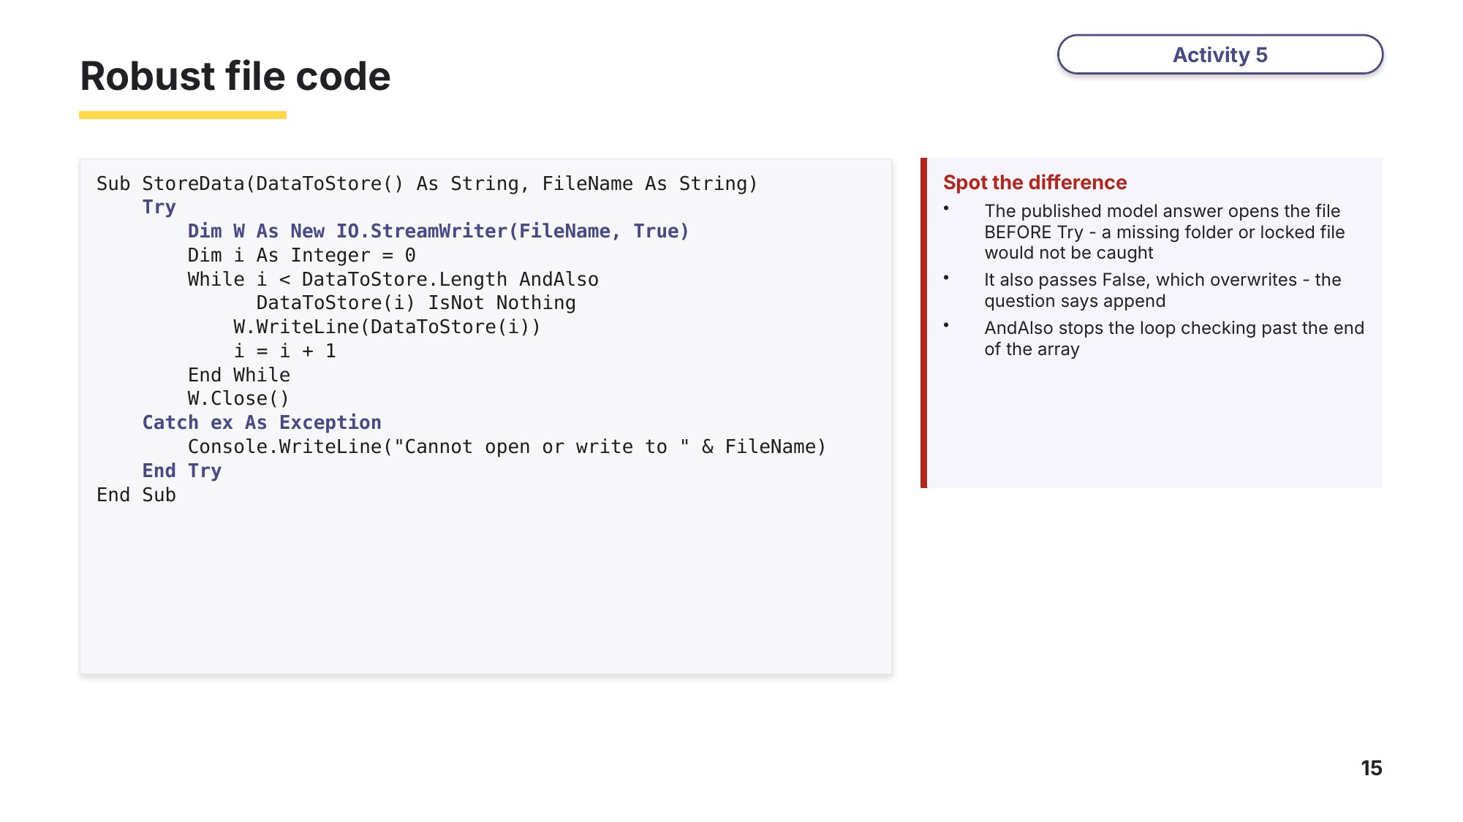
Slide 15 - Robust file code
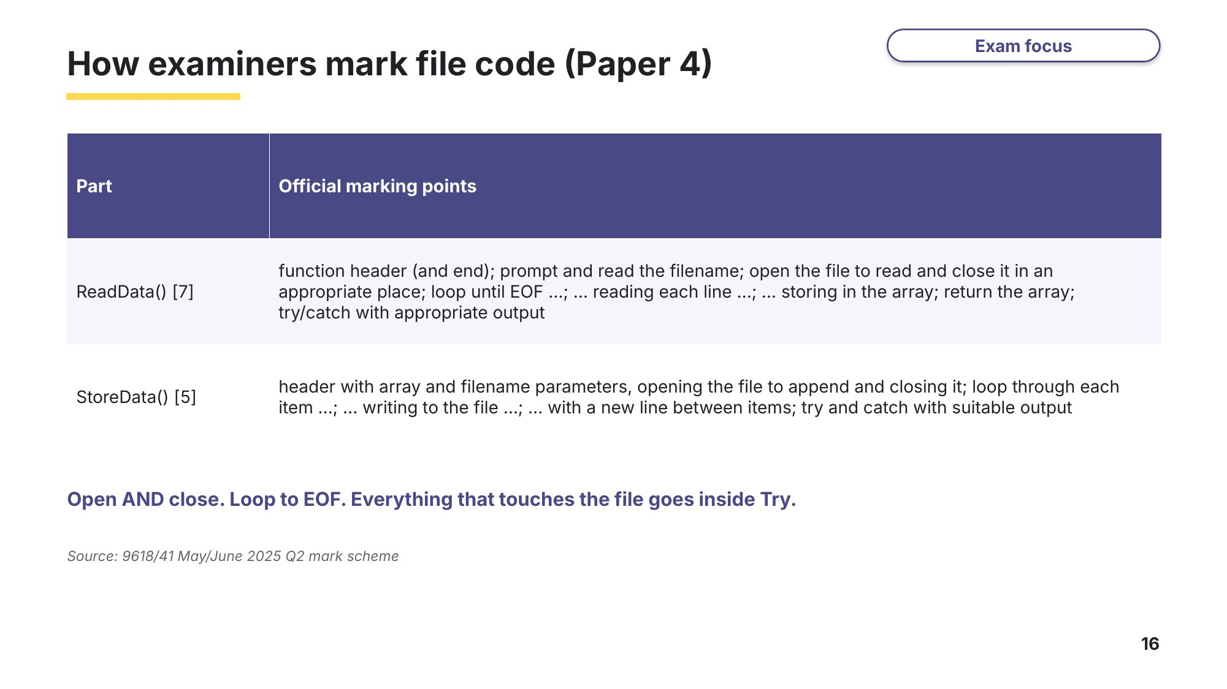
Slide 16 - How examiners mark file code
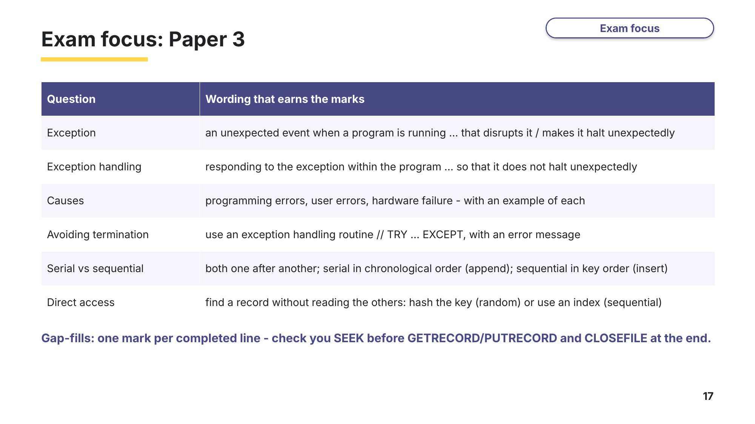
Slide 17 - Exam focus: Paper 3
Use these slides as a checklist when you mark Tasks 3 and 4, then try Task 5.
Task 5 Extension: find and fix the bugs [9 marks]
Part A Two bugs (VB.NET)
CopyNames() should add every name in Source to the END of Destination, in upper case, and output a message instead of crashing if Source does not exist. It has two bugs, marked line A and line B.
Sub CopyNames(Source As String, Destination As String)
' Adds every name in Source to the END of Destination, in upper case
Try
Dim Reader As New IO.StreamReader(Source)
Dim Writer As New IO.StreamWriter(Destination, False) ' <-- line A
While Not Reader.EndOfStream
Writer.WriteLine(UCase(Reader.ReadLine()))
End While
Reader.Close()
Writer.Close()
Catch ex As DivideByZeroException ' <-- line B
Console.WriteLine("Cannot copy " & Source)
End Try
End Sub
(a) Describe what goes wrong because of line A, and write the corrected line. [2]

(b) Describe what goes wrong because of line B when Source does not exist, and write the corrected line. [2]

Part B Copying records between random files (Paper 3)
9618/32 May/June 2025 Q13
The pseudocode algorithm below uses random file access to copy 50 records from a live file CurrentResults.dat to a stored file StoredResults.dat one record at a time. If any grades are missing in CurrentResults.dat, the text "Missing grade" is added to the ExamGrade field in StoredResults.dat. Complete this file handling pseudocode algorithm.
Write the missing code for gaps (1) to (5). [5]
TYPE StudentResult
DECLARE LastName : STRING
DECLARE FirstName : STRING
DECLARE ExamGrade : STRING
ENDTYPE
DECLARE Grade : StudentResult
DECLARE Position : INTEGER
(1) ........................
OPENFILE "StoredResults.dat" FOR RANDOM
(2) ........................
SEEK "CurrentResults.dat", Position
GETRECORD "CurrentResults.dat", Grade
IF Grade.ExamGrade = "" THEN
(3) ........................
ENDIF
(4) ........................
(5) ........................
NEXT Position
CLOSEFILE "CurrentResults.dat"
CLOSEFILE "StoredResults.dat"
Gap | Answer
(1)
(2)
(3)
(4)
(5)
Task 6 Build it: at the computer [25 marks]
9618/41 May/June 2025 Q2
A program reads data from a text file, splits the data depending on its content and stores the separated data into different files. The text file TheData.txt contains 72 lines of data. Each line of data has an integer number and a string colour that are separated by a comma. For example, the first line in the file is: 10,red The integer is 10 and the string is "red". The file contains six different colours: red, green, blue, orange, yellow, pink.
Save your program as Question2_J25. Put TheData.txt (from your teacher) in the bin\Debug folder of the project, and create six empty files: Blue.txt, Green.txt, Orange.txt, Pink.txt, Red.txt, Yellow.txt.
(a) The function ReadData(): prompts the user to enter a filename and reads this filename from the user; opens the file and reads each line of data into a 1D array; returns the populated 1D array. The function needs to work for a file that contains an unknown number of lines. Write program code for ReadData(). [7]
(b) The procedure SplitData() takes a 1D string array as a parameter with the identifier DataArray. The procedure declares six 1D arrays: one array for each colour that appears in the file (red, green, blue, orange, yellow, pink). The procedure accesses each string in DataArray. The data in each string is split into the integer and the colour. The integer is stored in the array that matches the colour. Write program code for SplitData(). [6]
(c) The procedure StoreData(): takes two parameters: a 1D array DataToStore and a filename; opens the text file with the filename that is passed as a parameter; appends each item of data from DataToStore to a new line in the text file; uses exception handling when opening and writing data to the text file. Write program code for StoreData(). [5]
(d) Each of the six colours has a blank text file where the numbers will be stored. The procedure SplitData() needs amending to call StoreData() six times, with each of the six colour arrays and the name of the text file that corresponds to that colour. For example, StoreData() will be called with the red array and the file name "Red.txt". Write program code to amend SplitData(). [2]
(e) (i) The main program calls ReadData() and then SplitData(). Write program code for the main program. [3]
(ii) Test your program. Input the text "TheData.txt" when prompted. Take a screenshot of the output(s) and a screenshot showing the content of the file that stores the red numbers. [2]
Predict first
Before you run (e)(ii), open TheData.txt and predict:
Question | Your prediction | After running
How many numbers will Red.txt contain?
What are the first three numbers in Red.txt?
What happens if you run the program twice?
What is output if you type Data.txt (a file that does not exist)?
Stretch
1 Change ReadData() so it catches IO.FileNotFoundException with its own message, and any other exception with a second message. Test both.
2 Add a line "15,purple" to a copy of the file. What does your program do? Make SplitData() skip and report lines with an unknown colour or no comma.
Learn Review
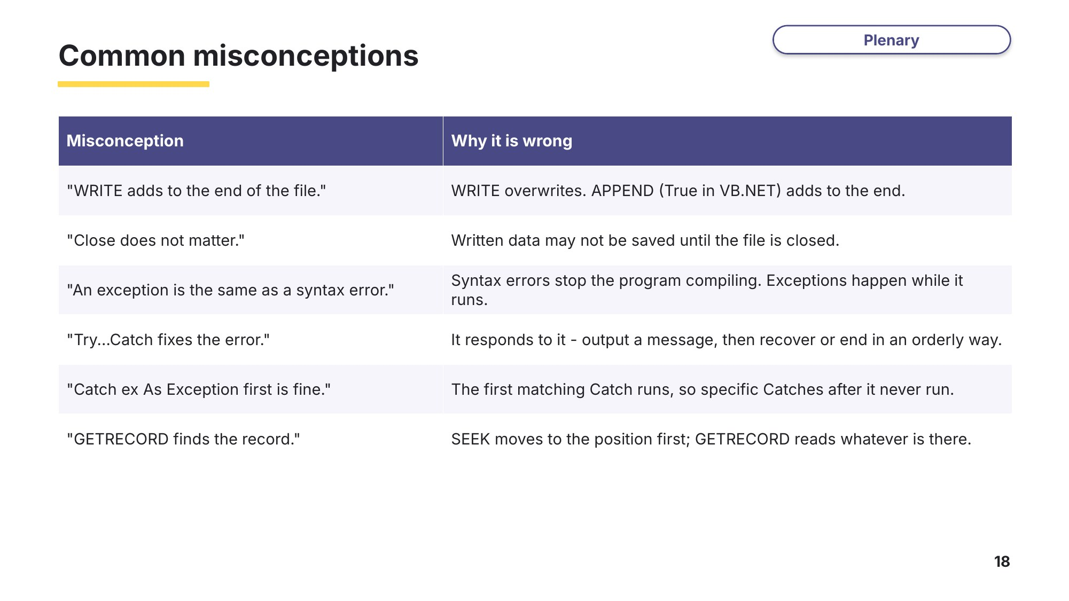
Slide 18 - Common misconceptions
Look back at your Task 1 answers. Change any that you now think are wrong.
Exit question
Try
Dim R As New IO.StreamReader("Data.txt")
Console.WriteLine(R.ReadLine())
R.Close()
Catch ex As IO.FileNotFoundException
Console.WriteLine("Data.txt not found")
End Try
(a) Which line throws the exception if Data.txt does not exist?

(b) What is output if the file is missing?

(c) How could you make sure R is always closed?

